EXERCISE NO 2

Date: DATA MANIPULATIONS

Create table statement:

**CREATE TABLE employees(employee_id NUMBER(6) NOT NULL,first_name VARCHAR2(20),last_name VARCHAR2(25) NOT NULL,email VARCHAR2(25) NOT NULL,phone_number VARCHAR2(20),hire_date DATE NOT NULL,job_id VARCHAR2(10) NOT NULL,salary NUMBER(8, 2),commission_pct NUMBER(2, 2),manager_id NUMBER(6),department_id NUMBER(4));**

Insert values:

**BEGIN**

**INSERT INTO employees (employee_id, first_name, last_name, email, phone_number, hire_date, job_id, salary, department_id, manager_id) VALUES (100, 'John', 'Doe', 'jdoe@example.com', '1234567890', TO_DATE('12-JAN-2020', 'DD-MON-YYYY'), 'IT_PROG', 6000, 60, NULL);**

**INSERT INTO employees (employee_id, first_name, last_name, email, phone_number, hire_date, job_id, salary, department_id, manager_id) VALUES (101, 'Jane', 'Smith', 'jsmith@example.com', '0987654321', TO_DATE('15-FEB-2020', 'DD-MON-YYYY'), 'HR_REP', 4500, 70, 100);**

**INSERT INTO employees (employee_id, first_name, last_name, email, phone_number, hire_date, job_id, salary, department_id, manager_id) VALUES (102, 'Alice', 'Johnson', 'ajohnson@example.com', '5551234567', TO_DATE('01-MAR-2021', 'DD-MON-YYYY'), 'SALES', 4200, 70, 100);**

**INSERT INTO employees (employee_id, first_name, last_name, email, phone_number, hire_date, job_id, salary, department_id, manager_id) VALUES (103, 'David', 'Williams', 'dwilliams@example.com', '9876543210', TO_DATE('10-APR-2022', 'DD-MON-YYYY'), 'MARKETING', 7200, 80, NULL);**

**INSERT INTO employees (employee_id, first_name, last_name, email, phone_number, hire_date, job_id, salary, department_id, manager_id) VALUES (104, 'Emily', 'Brown', 'ebrown@example.com', '1112223333', TO_DATE('20-MAY-2023', 'DD-MON-YYYY'), 'FINANCE', 6800, 60, NULL);**

**INSERT INTO employees (employee_id, first_name, last_name, email, phone_number, hire_date, job_id, salary, department_id, manager_id) VALUES (105, 'Michael', 'Davis', 'mdavis@example.com', '4445556666', TO_DATE('05-JUN-2024', 'DD-MON-YYYY'), 'IT_PROG', 7500, 60, NULL);**

**INSERT INTO employees (employee_id, first_name, last_name, email, phone_number, hire_date, job_id, salary, department_id, manager_id) VALUES (106, 'Olivia', 'Miller', 'omiller@example.com', '7778889999', TO_DATE('15-JUL-2024', 'DD-MON-YYYY'), 'HR_REP', 5200, 50, NULL);**

**INSERT INTO employees (employee_id, first_name, last_name, email, phone_number, hire_date, job_id, salary, department_id, manager_id) VALUES (107, 'Noah', 'Wilson', 'nwilson@example.com', '2223334444', TO_DATE('25-AUG-2024', 'DD-MON-YYYY'), 'SALES', 6200, 30, NULL);**

**INSERT INTO employees (employee_id, first_name, last_name, email, phone_number, hire_date, job_id, salary, department_id, manager_id) VALUES (108, 'Ava', 'Taylor', 'atailor@example.com', '5556667777', TO_DATE('05-SEP-2024', 'DD-MON-YYYY'), 'MARKETING', 7800, 40, NULL);**

**INSERT INTO employees (employee_id, first_name, last_name, email, phone_number, hire_date, job_id, salary, department_id, manager_id) VALUES (109, 'Liam', 'Thomas', 'lthomas@example.com', '8889990000', TO_DATE('15-OCT-2024', 'DD-MON-YYYY'), 'FINANCE', 7000, 20, NULL);**

**END;**

**/**

TABLE PREVIEW:

**SELECT * FROM EMPLOYEES;**

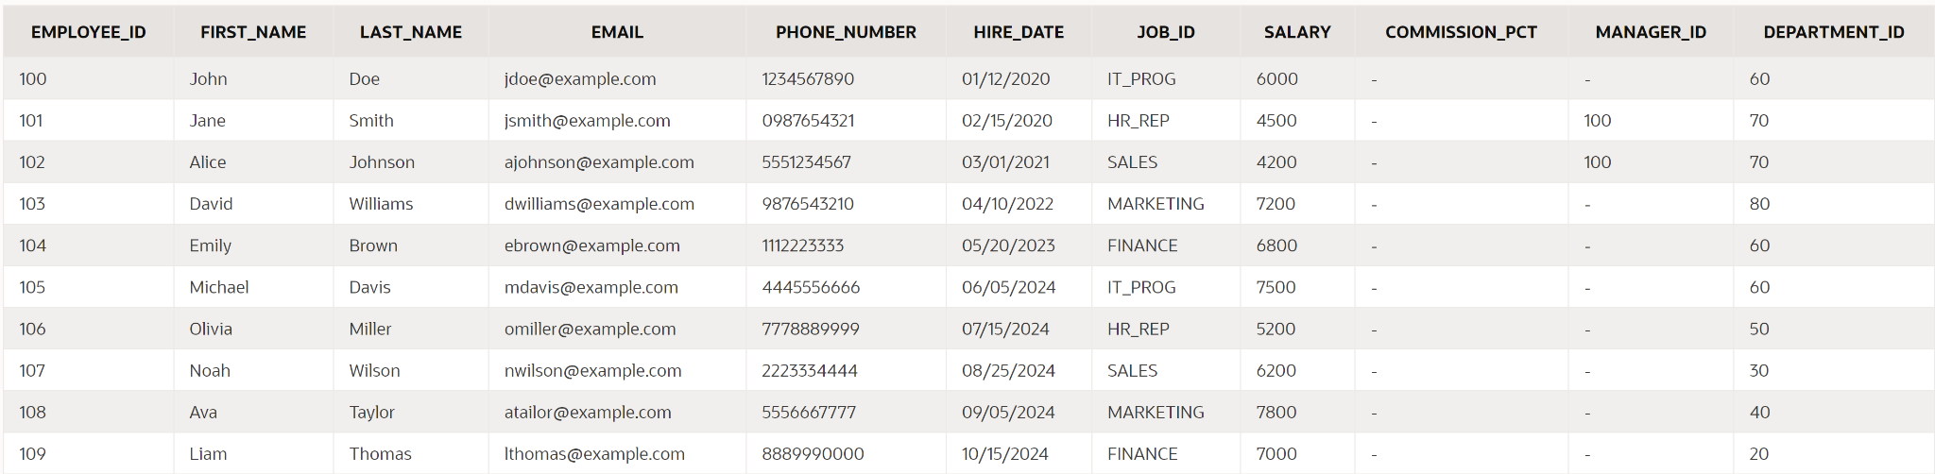

1.Create the following tables with the given structure.

EMPLOYEES TABLE

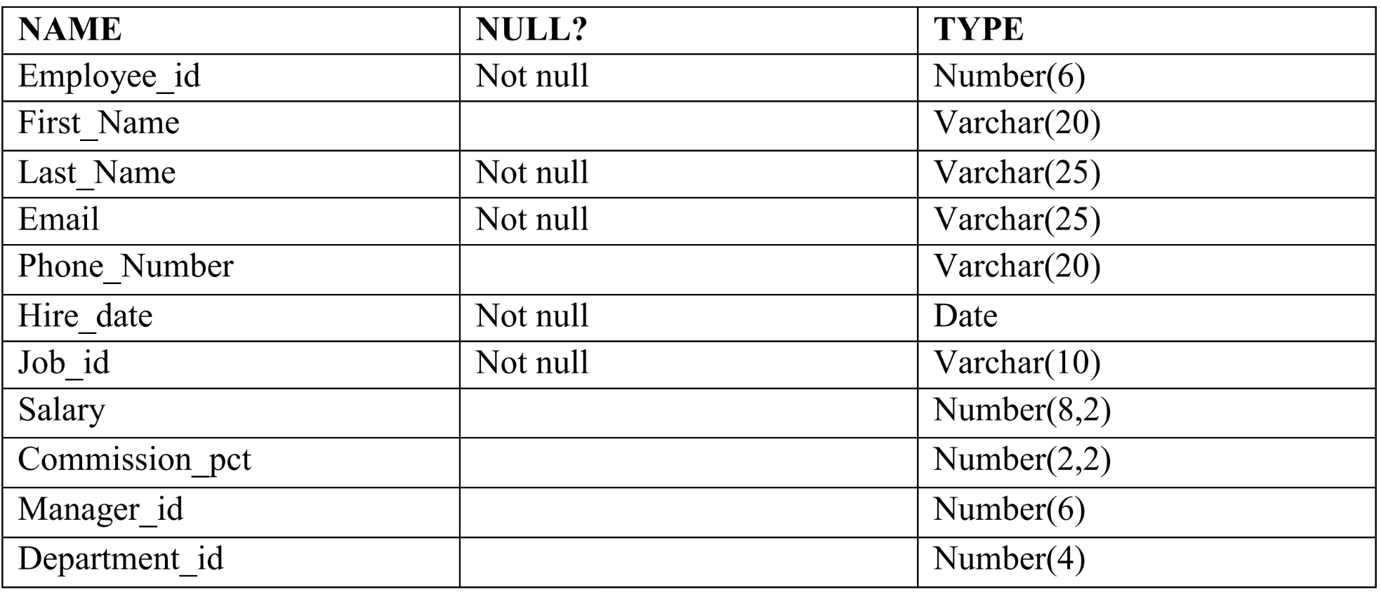

**CREATE TABLE employees(employee_id NUMBER(6) NOT NULL,first_name VARCHAR2(20),last_name VARCHAR2(25) NOT NULL,email VARCHAR2(25) NOT NULL,phone_number VARCHAR2(20),hire_date DATE NOT NULL,job_id VARCHAR2(10) NOT NULL,salary NUMBER(8, 2),commission_pct NUMBER(2, 2),manager_id NUMBER(6),department_id NUMBER(4));**

CHECK:

**DESC EMPLOYEES;**

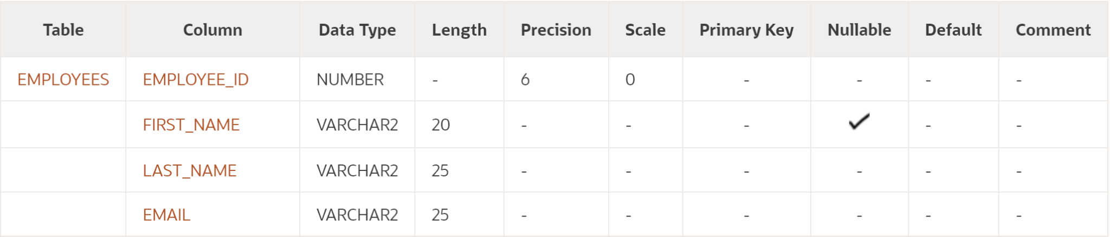

(a) Find out the employee id, names, salaries of all the employees

PROGRAM:

**SELECT employee_id, first_name, last_name, salary FROM employees;**

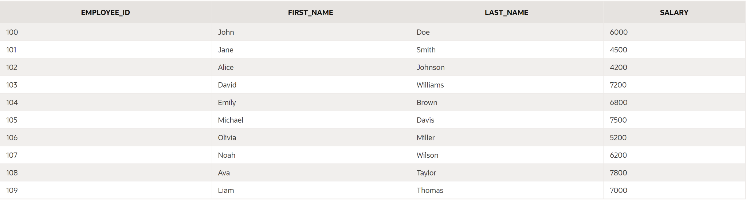

(b) List out the employees who works under manager 100

PROGRAM:

**SELECT employee_id, first_name, last_name FROM employees WHERE manager_id = 100;**



(c) Find the names of the employees who have a salary greater than or equal to 4800

PROGRAM:

**SELECT first_name, last_name, salary FROM employees WHERE salary >= 4800;**

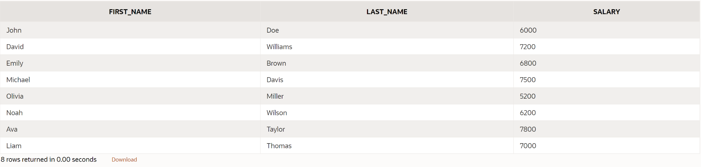

(d) List out the employees whose last name is ̳AUSTIN‘

PROGRAM:

**SELECT first_name, last_name FROM employees WHERE last_name = 'AUSTIN';**



(e) Find the names of the employees who works in departments 60,70 and 80

PROGRAM:

**SELECT first_name, last_name FROM employees WHERE department_id IN (60, 70, 80);**

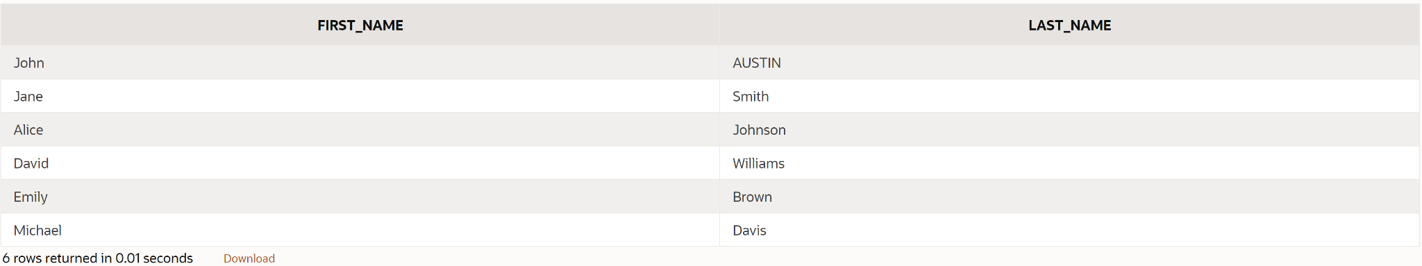

(f ) Display the unique Manager_Id.

PROGRAM:

**SELECT DISTINCT manager_id FROM employees;**



Create an Emp table with the following fields: (EmpNo, EmpName, Job,Basic, DA, HRA,PF,

GrossPay, NetPay) (Calculate DA as 30% of Basic and HRA as 40% of Basic)

(a) Insert Five Records and calculate GrossPay and NetPay.

(b) Display the employees whose Basic is lowest in each department.

(c) If Net Pay is less than

1. Create the DEPT table based on the DEPARTMENT following the table instance chart

below. Confirm that the table is created.

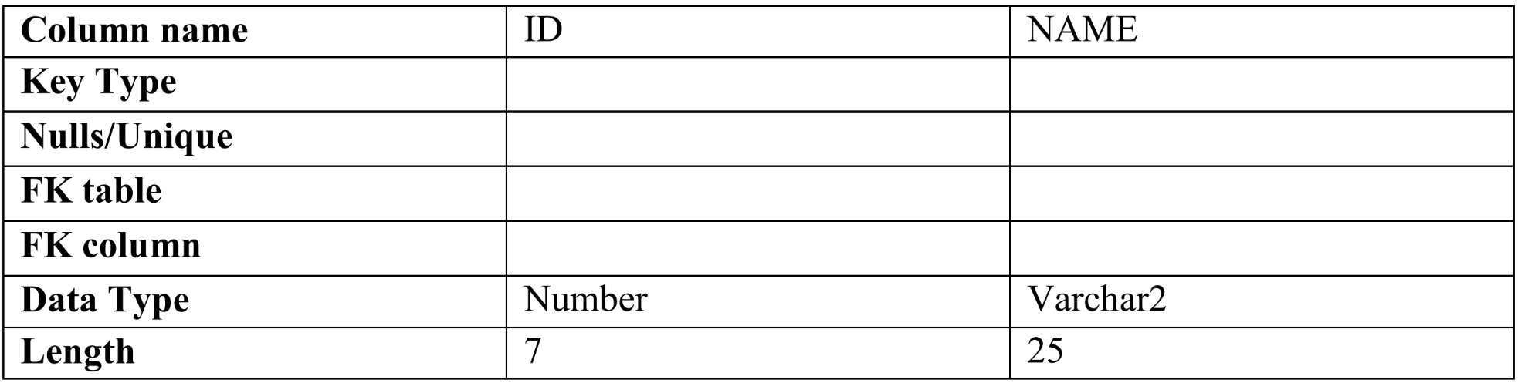

PROGRAM:

**CREATE TABLE departments (department_id NUMBER(6) NOT NULL,department_name VARCHAR2(25),manager_id NUMBER(6),location_id NUMBER(4));**

CHECK:

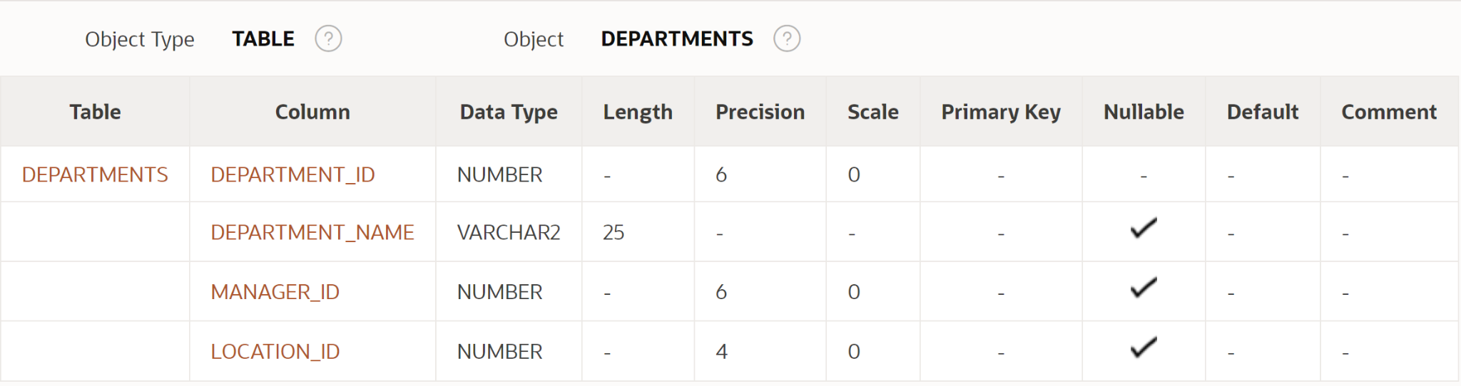

2. Create the EMP table based on the following instance chart. Confirm that the table is

created.

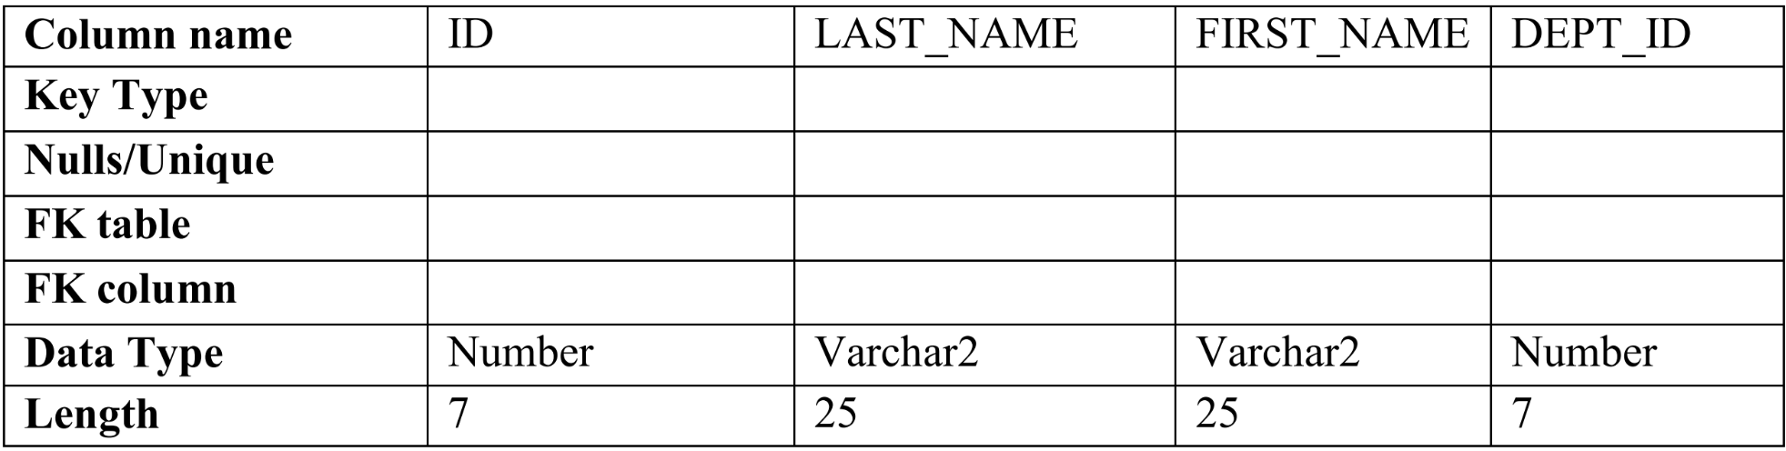

PROGRAM:

3 Modify the EMP table to allow for longer employee last names. Confirm the

modification.(Hint: Increase the size to 50)

PROGRAM:

**CREATE TABLE emp (EmpNo NUMBER(6) PRIMARY KEY,EmpName VARCHAR2(50),Job VARCHAR2(30),Basic NUMBER(10, 2),DA NUMBER(10, 2),HRA NUMBER(10, 2),PF NUMBER(10, 2),GrossPay NUMBER(10, 2),NetPay NUMBER(10, 2));**

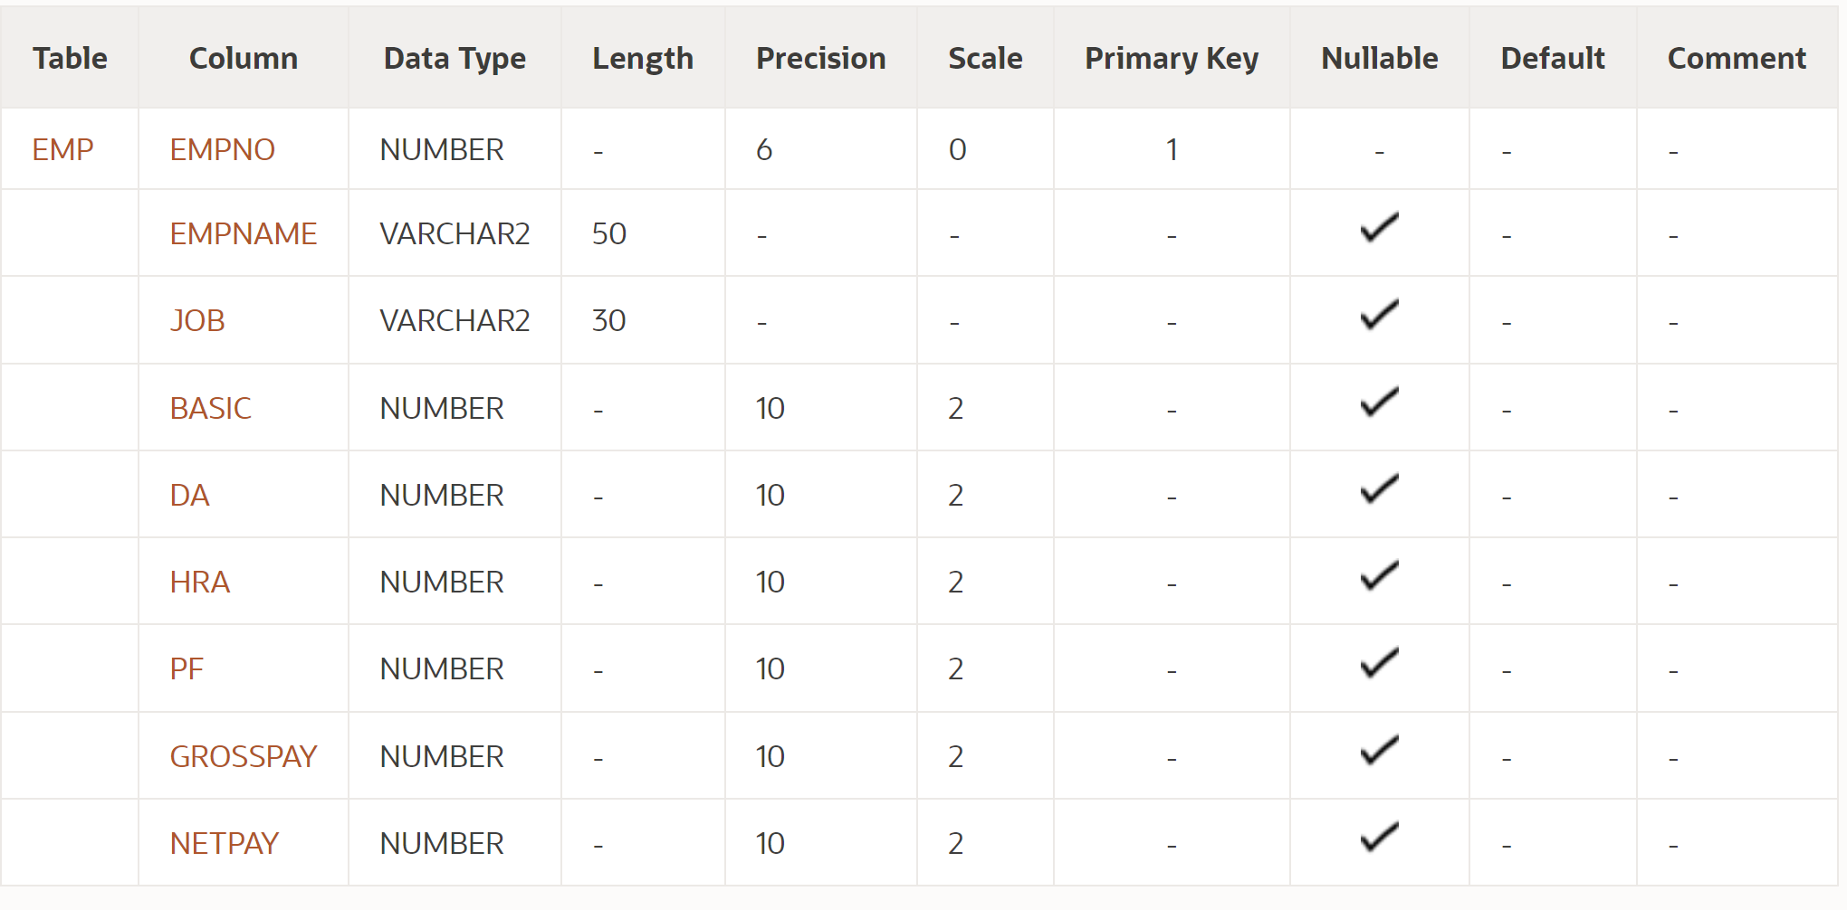

4 Create the EMPLOYEES2 table based on the structure of the EMPLOYEES table. Include

Only the Employee_id, First_name, Last_name, Salary and Dept_id columns. Name the

columns Id, First_name, Last_name, salary and Dept_id respectively.

5 Drop the EMP table.

6 Rename the EMPLOYEES2 table as EMP.

7 Add a comment on the DEPT and EMP tables. Confirm the modification by describing the

table.

8 Drop the First_name column from the EMP table and confirm it.